28. Create devleopers group

29. Create usera with immediate change of password when login and addd this user to develoeprs group

30. Create a policy s3 readonly access and attach to develoeprs group

31. login with usera and verify he has only s3 read-only access

32. Create userb

33 .Create ec2 full access and s3 full access policy and attached that policy to user-b

34. verify user has ec2,s3 full aceess via console

35. Create list-only s3+ec2 access for user-c. verify same from console (create using policy creater-ui)

36. Create accesskey and secret keys and configure aws cli on windows local machine

37. Run aws configure command it will ask for ur access/secret keys and then u will get access to your aws cloud from your local.

which mean you can do all operations form aws cli.

38. Create s3 bucket using aws cli

39. Create ec2 instance using aws cli

40. Create iam user using aws cli

41. Create policy using aws cli

42. Attach policy to user using aws cli

28. Create devleopers group

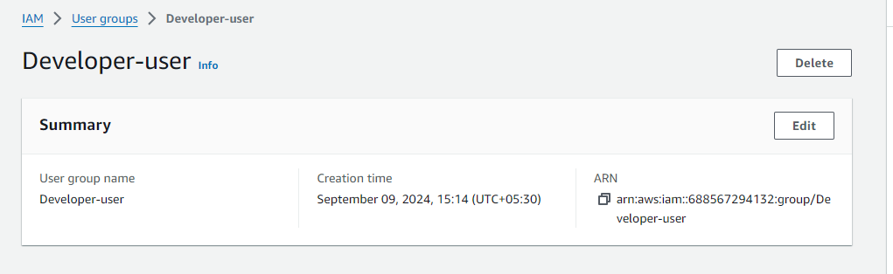

29. create usera with immediate change of password when login and addd this user to develoeprs group

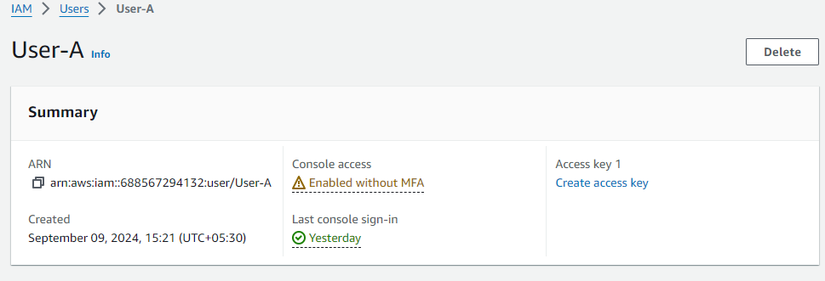

* User-A is added to the group developer-User

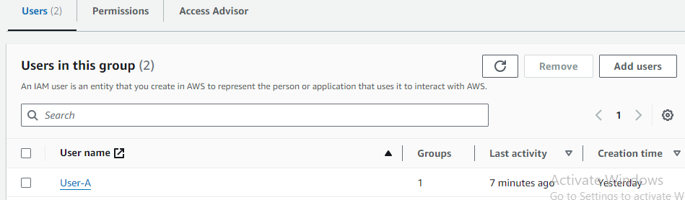

30. Create a policy s3 readonly access and attach to develoeprs group

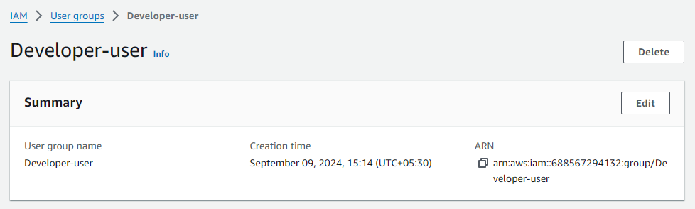

* Attached the s3 readonly access to the developer-user

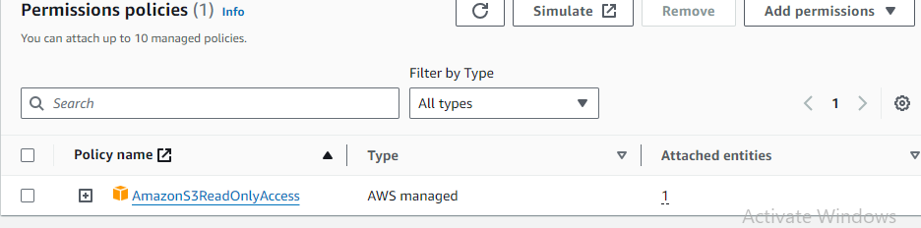

31. Iogin with usera and verify he has only s3 read-only access

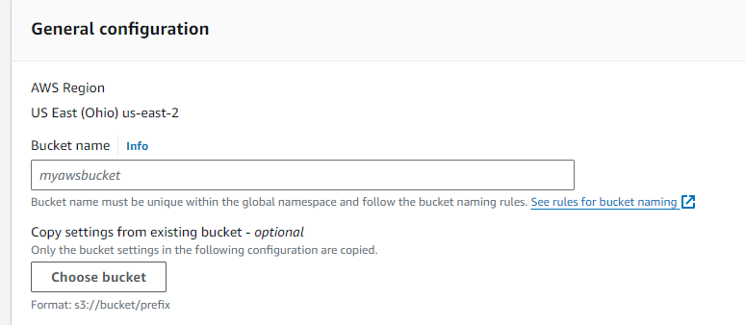

32. Create userb

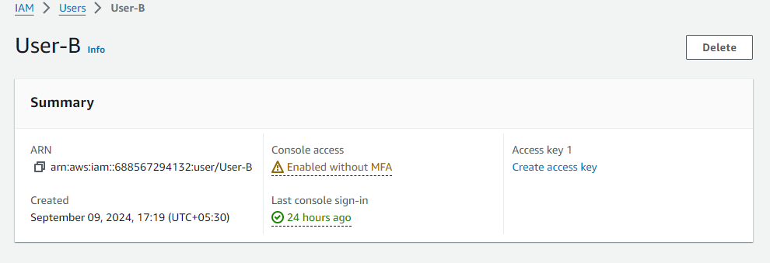

33 .Create ec2 full access and s3 full access policy and attached that policy to user-b

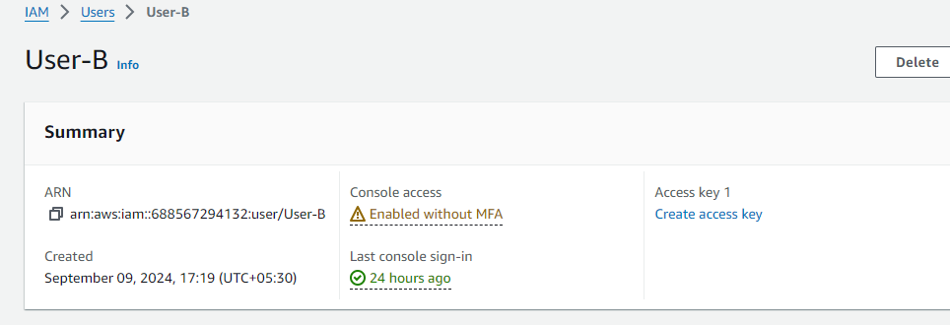

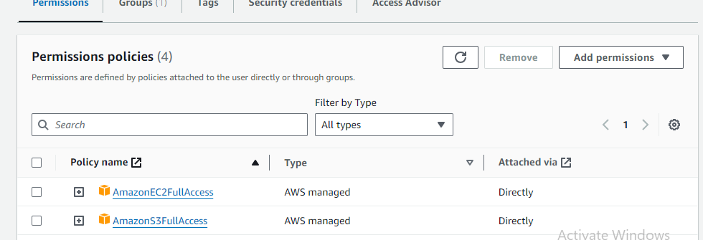

34. verify user has ec2,s3 full aceess via console

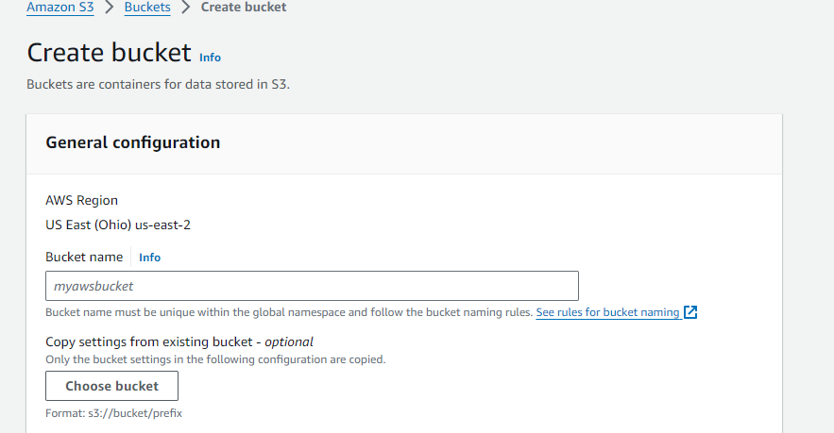

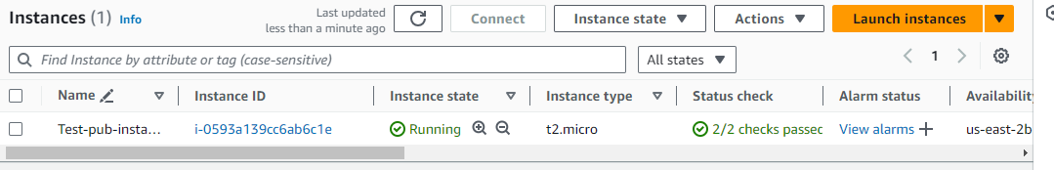

35. create list-only s3+ec2 access for user-c. verify same from console (create using policy creater-ui)

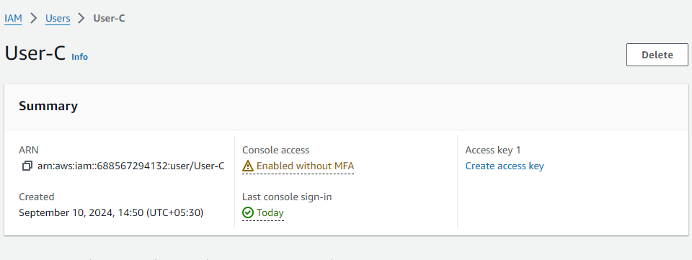

* Created the S3 and EC2 policies and attached to the user-c

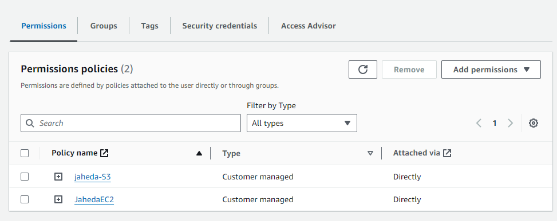

Using user-c EC2 instance be accessed

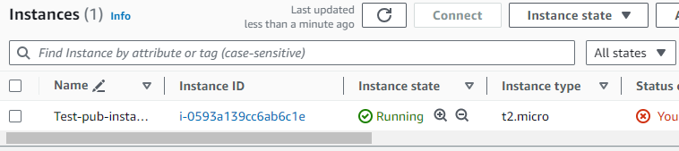

* Using user-c S3 service be created

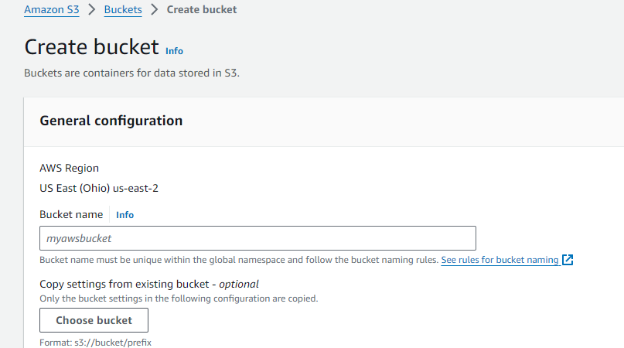

. create accesskey and secret keys and configure aws cli on windows local machine

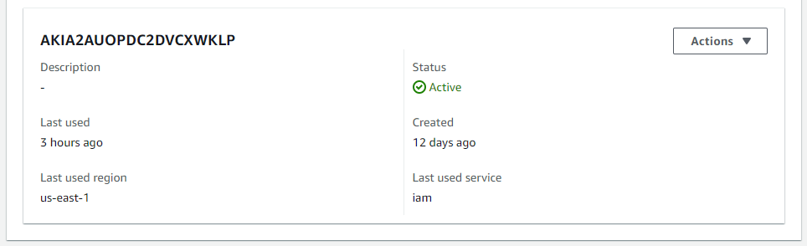

37. Run aws configure command it will ask for ur access/secret keys and then u will get access to your aws cloud from your local.

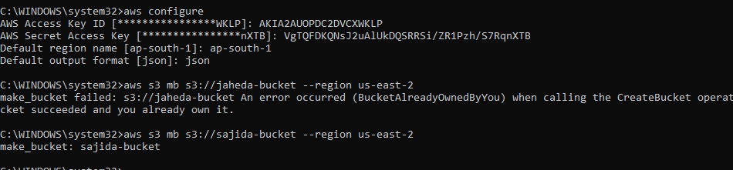

38. Create s3 bucket using aws cli

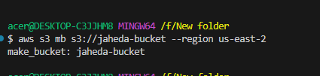

39. Create ec2 instance using aws cli

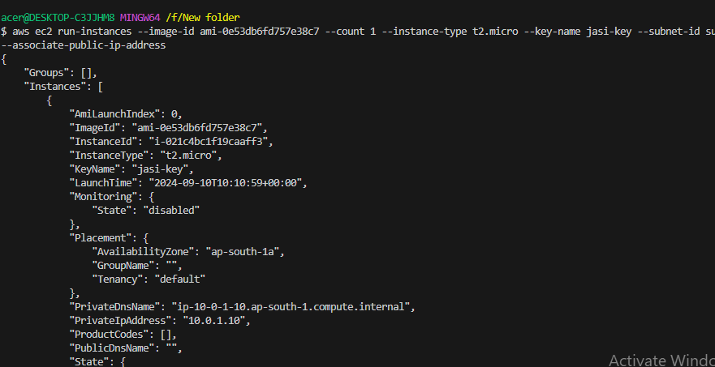

39.Create iam user using aws cli

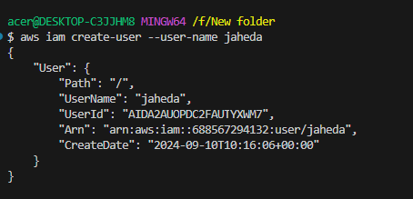

41. create policy using aws cli

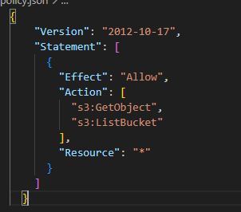

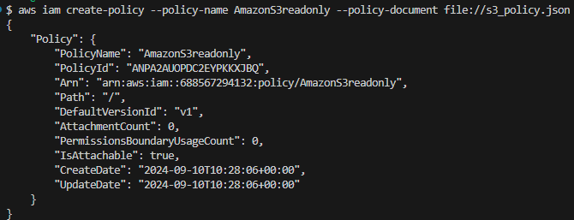

42. Attach policy to user using aws cli

